The doc is prepared for factory operators for how to safely use manufacturing tool.

# PC requirement

* **CPU**: Intel E3400 or higher, Frequency: 2GHz+
* **Memory**: 1GB+
* **OS**: Windows XP/Windows 7 version. Administration account is necessary to install driver (For i.mx35/51/53).
* **USB2.0 root hub is a must, NO USB 1.1 root hub is allowed.**

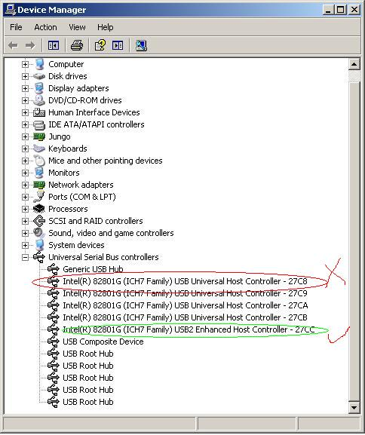

* **External USB hub is allowed with below restrictions:**
  + **Must use independent power supply**
  + **Must pass the compliance test of USB org, Belkin USB hub is recommended.**
  + **No more 3 devices are allowed to be connected to USB hub.**

# Operation flow

## For i.mx35/51/53 platform, below steps must be followed.

**Warning： Below steps must be followed, or you may find your PC gets blue screen.**

1. Open Mfgtool.exe on PC side.
2. Connect products to PC through USB cable. Don’t power on any of them.
3. Power on all products at the same time. To do this, please make sure you use a power socket with On/Off switch for power supply.

Warning: Don’t be idle after power on, go to next step ASAP, or you may get blue screen on your PC.

1. Click start button (the green block in below snapshot) in Mfgtool’s panel.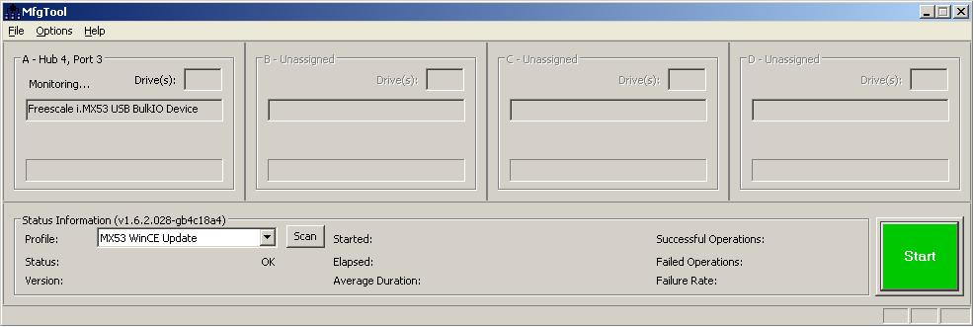
2. Wait till all products’ burning work finished. You can find the progress bar turns to green.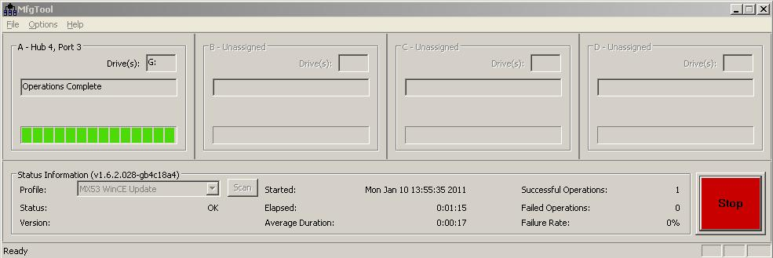
3. Click Stop button.
4. Powered off all products and disconnect them from PC.
5. Go to Step 2 for next round.

## For other platforms, below step should be followed:

1. Open Mfgtool.exe on PC side.
2. Connect products to PC through USB cable and power on them.
3. Click start button (the green block in below snapshot) in Mfgtool’s panel.
4. Wait till all products’ burning work finished. You can find the progress bar turns to green.
5. Powered off all products and disconnect them from PC.
6. Connect next round products to PC through USB cable and power on them.
7. Go to Step 4.

# How to handle error during operation

* Plug out the device which failed to be burned and replug it in. Mfgtool will automatically re-burn it. If it still failed to be burned, don’t retry and check other factors like hardware integrity. Don’t do any operation on Mfgtool UI during the operation.
* After you connect the device into USB and press “Start” button, you may find “Please connect device” showed in Mfgtool UI sometimes. It can be fixed by repluging the device. Don’t do any operation on Mfgtool UI during the operation.
* After you connect the device into USB, you may find no “Freescale i.MX53 USB Bulk-IO device” showed in Mfgtool UI sometimes. It can be fixed by repluging the device, and press “Scan Devices” button.